Criteria for Employment as a Substitute Teacher:
- Must possess, a GED or High School Diploma with at least a 2.0 GPA earned at least five (5) years prior to the date of application.;
- Completion of a college degree from an accredited college or university or;
- Hold a valid or expired Teacher Certification and
- Have a clear criminal record

Step 1.__ Complete the Substitute Teacher Application
Step 2.__ Complete the sample writing and math exercise
Step 3.__ Complete an interview with one Principal. (Principal of your choice and set up by you)
Step 4.__ Complete Substitute Training at the RESA (Only those applicants not holding valid or expired Teacher Certifications and a fee is usually associated with this training. Approx. $40.00)
Step 5.__ Complete Criminal Background Check (Registration instructions attached)
Step 6.__ Submit Transcripts or copy of Teacher Certification (whichever one is applicable)
Step 7.__ Complete the Child Abuse and Neglect: Mandated Reporting Training (Instructions attached)
Step 7.__ Read and sign National Child Protection Act/Volunteers for Children Act Waiver and Consent Form

Please note: Completion of the application process does NOT guarantee that the applicant is automatically added the substitute list. All applicants will be reviewed by the HR Director then approved by the Board of Education during the monthly board meeting.

Keep in mind that Substitute Teachers work on an “AS NEEDED” basis and are not guaranteed to be actually called for work at any school or for any minimum length of time. Substitute Teachers must be willing to work at any school when called.

Keep Top page for reference

Expecting All Children to Excel in Academics,

Arts and Athletics

Washington County Board of Education
Dr. Rickey L. Edmond, Superintendent
501 Industrial Drive
P O Box 716
Sandersville, GA 31082
(478) 552-3981

Substitute Teacher Application for Employment

Date: _____________________________

Name: __________________________________________________________

Mailing Address: __________________________________________________
_________________________________________________

Email Address: ____________________________________________________

Social Security Number: ____________________________________________

Telephone Number: _______________________________________________

Education:

 | Name of School | City, State | Diploma/Major | Dates Attended | Date Graduated
High School
Tech College
College

Other

Previous Work Experience (list most recent employer first):

SUPERVISOR’S name | business name | address | phone no.
1.

Job Title/ Basic Duties: |  |  | Dates Employed:
2.

Job Title/ Basic Duties: |  |  | Dates Employed:
3.

Job Title/ Basic Duties: |  |  | Dates Employed:
Professional References

name | address | phone number | relationship

Please answer each of the following questions:

Have you ever:

Yes ( ) No ( ) Pled guilty or no contest to, or been convicted of any offense
relating to the manufacture, distribution, sale or possession of any illegal drugs?
Yes ( ) No ( ) Pled guilty or no contest to, or been convicted of any misdemeanor or felony
criminal offense other than a minor traffic offense?
Yes ( ) No ( ) Resigned, been terminated, or non-renewed from employment position for
committing a misdemeanor of moral turpitude?
Yes ( ) No ( ) Received an unsatisfactory performance evaluation from any employer?
Yes ( ) No ( ) Received a dishonorable discharge from the armed services?

APPLICANTS NAME:______________________________________

Step 2. Writing Sample (must be completed in your own handwriting):

On the lines below, explain why you would like to become a substitute teacher in the Washington County Public Schools. Explain what characteristics you possess that would make you qualified to serve as a substitute teacher. Please write your answer in your own handwriting using a blue or black pen.

________________________________________________________________________

________________________________________________________________________

________________________________________________________________________

________________________________________________________________________

________________________________________________________________________

________________________________________________________________________

________________________________________________________________________

________________________________________________________________________

________________________________________________________________________

________________________________________________________________________

Math Skills Worksheet

1) The Junior Beta Club is making food baskets for the local homeless shelter. They asked for donations and they received 88 cans of food and 44 loaves of bread. If they want all the baskets to be the same with nothing left over, how many baskets can they make and how many of each item will be in each basket?

2) Keesha baked 4 dozen oatmeal cookies and 30 chocolate chip cookies. She wants to divide the cookies into plastic containers with the same amount of cookies in each container. If she wants the container to hold the greatest number of cookies possible how many containers does she need and how many of each cookie will be in each container?

3) 42 + 12 = 6(7+2) Is it true or false? Explain your thinking.

4) 6(7+2) = (6 x 7) + (6 x 2) Is it true or false? Explain your thinking.

5) 6(7 + 2) = (6 x 7) + (6 x 2) = 42 + 12 Is it true or false? Explain your thinking.

6) How is 6 related to 42 and 12?

Find all of the common factors for each of the expressions.

7) 64 + 32

8) 72 + 12

9) 45 + 18

10) 51 + 21

By filing an application for employment with the Washington County School district, if employed, I agree to abide by all policies as set forth by the Washington County Board of Education. I authorize full investigation of the information given in this application and consent to the representatives of the Washington County Board of Education contacting my references, previous employers, schools attended, and law enforcement authorities. I also understand any misstatement or omission of any information requested shall be a reason for non-employment or dismissal from employment.

I understand that my application is not complete until transcripts, professional references and all supporting documents are submitted to the Human Resources department. I also understand the application; transcripts, references and other data are the property of the Washington County Board of Education and will not be returned.

I understand that WCBOE will require completion of a background check in order to qualify for this job. This includes checking FBI records in order to verify any criminal history. Disclosure of any Criminal History prior to performing this check will assist us in determining if you qualify for this job. By signing below, I agree to perform the fingerprinting required of a background check, and grant WCBOE permission to receive and verify any information provided on this application

Applicant’s Signature _____________________________________Date_____________

All persons employed in the Washington County Schools must be approved by the Washington County Board of Education. Therefore, no employment is official until it has been confirmed at a meeting of the Board of Education. Applications are kept in our active file two years from the date of the application. It is the responsibility of the applicant to re-apply after that time.

THE WASHINGTON COUNTY BOARD OF EDUCATION IS AN EQUAL OPPORTUNITY EMPLOYER. IT DOES NOT DISCRIMINATE AGAINST ANY EMPLOYEE OR APPLICANT FOR ANY REASON OF RACE, COLOR, NATIONAL ORIGIN, CREED, MARITAL STATUS, SEX, PHYSICAL HANDICAP, OR AGE.

National Child Protection Act/Volunteers for Children Act
Waiver and Consent Form

The criminal history record checks performed under the National Child Protection Act (NCPA), as amended by the Volunteers for Children Act (VCA), will determine if you, as a care provider (current or prospective employee, volunteer, contractor/vendor, or owner/operator), have been convicted of crimes that bear upon your fitness to be responsible for the safety and well-being of children (persons less than 18 years old), the elderly (persons 60 years of age or older), or individuals with disabilities (persons with a mental or physical impairment who require assistance to perform one or more daily living tasks). Pursuant to the NCPA/VCA, this form must be completed and signed by every current or prospective provider for whom criminal history records are requested by a Governmental Qualified Entity (QE). QEs provide care, treatment, education, training, instruction, supervision, recreation, care placement services, or license/certify others who provide care to vulnerable populations (children, the elderly, or individuals with disabilities).

Requesting QE Information:
QE Name
QE Address
QE Telephone Number

I am a current or prospective (check one): ___ Employee ___ Volunteer ___ Contractor/Vendor ___ Owner/Operator

I have been convicted of or pled guilty to a crime. ___ No ____ Yes
If yes, please provide a description of the crime and the particulars of the conviction on the back of this waiver.

I hereby authorize the requesting QE to submit a set of my fingerprints to the Connecticut State Police Bureau of Identification (SPBI) and Federal Bureau of Investigation (FBI) for the purpose of accessing and reviewing state and national criminal history records that may pertain to me. I further understand the following:
- My fingerprints will be used to check the criminal history records of the SPBI and the FBI;
- I can receive a state criminal history record from the SPBI and a national criminal history record from the FBI pursuant to Title 28, Code of Federal Regulations, §16.30-16.34;
- I am entitled to challenge the accuracy and completeness of any information contained in such records;
- The QE may choose to deny me unsupervised access to persons to whom the QE provides care until the criminal history record check is completed; and
- I may obtain a prompt determination as to the validity of my challenge before a final decision is made.

By signing this Waiver, it is my intent to authorize the dissemination of any state or national criminal history record which may pertain to me, to the requesting QE. I have read and understood the foregoing and the information provided is true and accurate to the best of my knowledge and belief.

*Printed Name:_________________________________ Signature:___________________________________________

*Date of Birth:______________________ *Address:______________________________________________________
*as it appears on a valid identification document issued by a governmental agency

NOTE: A copy of this document must be retained by the QE for at least one year of fingerprint submission date.

Navigation Instructions to the Child Abuse and Neglect: Mandated Reporting Requirements for Employees Volunteers and Contractors of Georgia Public Schools.
- Go to website: https://www.prosolutionstraining.com/content/?id=114/Home/

- Scroll down to the third paragraph and click the “click here” hyper link at the end of the paragraph.

- Select State: Georgia

- Scroll down and select: Health and Safety
- Select: Child Abuse and Neglect: Mandated Reporting Requirements for Employees, Volunteers, and contractors of Georgia Public Schools

- Click “add to cart” then click on the icon that it changes to

- Go down to “Purchase Now” and click

- Complete the order

Continue to follow the directions from there to complete the training session. There is no cost.
Remember to print out your certificate at the end of the course.

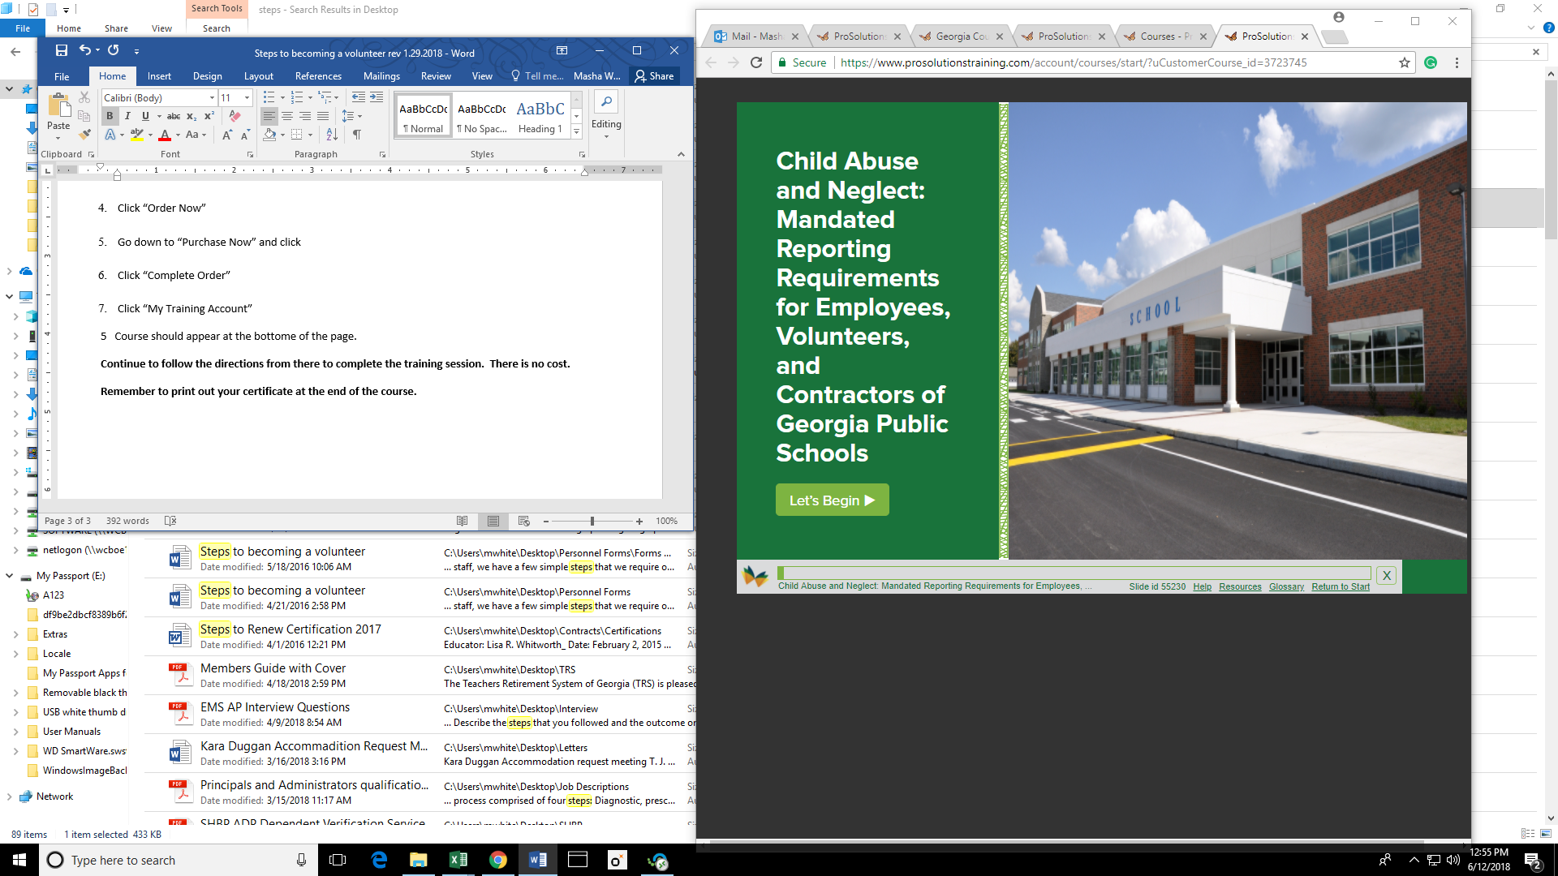

Registration instructions for fingerprinting

Fingerprinting: Employees are required to have prints done electronically using the Cogent LiveScan system. Cost is $51.50. Register online at: https://www.aps.gemalto.com/index.htm
(Choose Georgia)

Once you are at the home page:
Select Applicant Registration
Select Education Agencies (EA)
Select Public Schools
ORI number is GA931425Z
Fill in the information requested in each field
Purpose code is School Employment – Public Schools

Payment options are by debit or credit card at the time of registration. You MUST print and bring your registration confirmation sheet OR bring your confirmation number with you to your fingerprinting appointment. We cannot retrieve your registration information.

Washington County Board of Education Fingerprinting Schedule
Thursday 9am-11am
No appointment necessary

